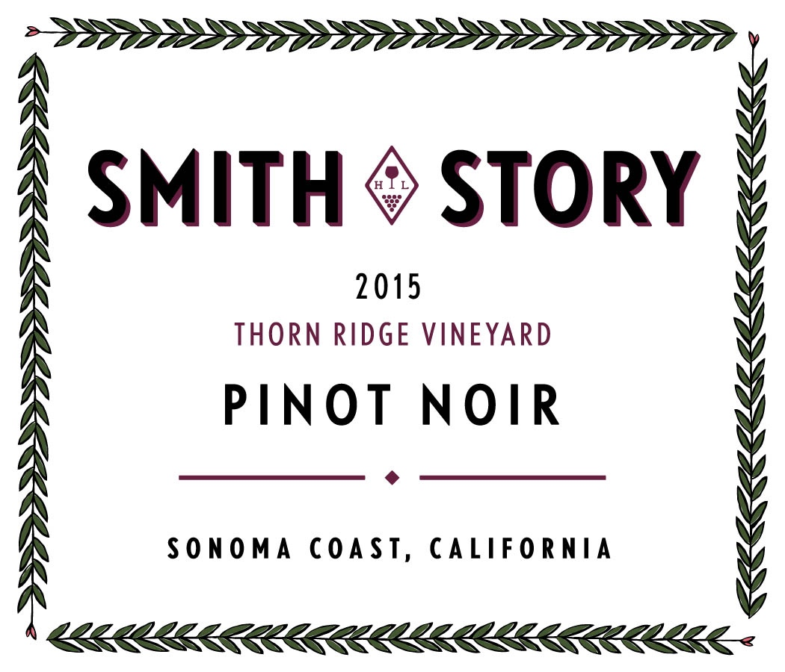
It all starts with the nose this year, oh the heavenly aromas of perfectly ripe plums, sweet cherries and savory violets and orange spices. Our smallest production due to the mark Mother Nature made on 2015...very small yields in the vineyard - but extraordinary quality grew on the vines.
Palate- bright and vibrant acidity, tannin that gives great texture but is subtle, notes of cherry and raspberry, it is a very mouth filling and mouthwatering wine, lush yet restrained, finishes with great texture and mouthfeel,
lingers oh does this wine linger on the palate!
This wine is intense, complex and one for your cellar too.

Vineyard location: Sebastopol Hills
(sub-section of the proposed West Sonoma Coast Appellation)
Soils: Goldridge Sandy Loam
Clones: 667, Pommard & 777
Harvest Dates: 8.20.15 and 8.24.15 at an average brix of 23
Aging: 16 months in French Oak (25% new)
Details: TA 6.5 g/L, pH 3.29 and 12.9% alcohol
Production: 63 cases
SRP: $80 94pts, AG Vinous.com

www.smithstorywinecellars.com

